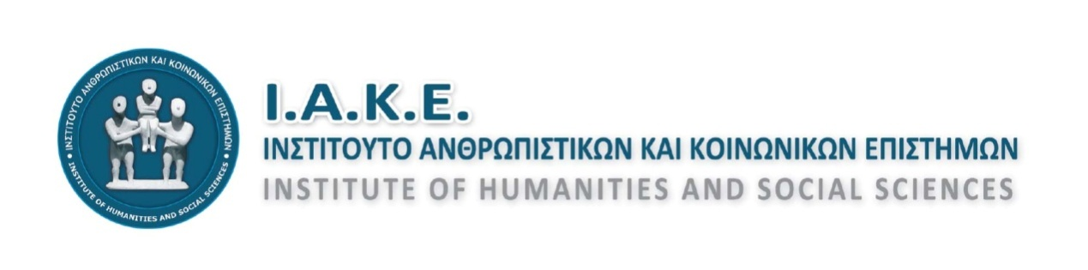

**4th International Conference**

"Democracy, rights and inequalities in the era of economic crisis.

Challenges in the field of research and education"

***27 - 29 April 2018  Heraklion, Crete, Greece***

**2nd ANNOUNCEMENT**

The Institute of Humanities and Social Sciences announces to the scientific community and to any interested party that it is planning to organize the 4th International Scientific Conference under the central topic: **"Democracy, rights and inequalities in the era of economic crisis. Challenges in the field of research and education"**

Through this Conference, we aim to discourse on democratic institutions and their functioning in today's social, political, economic, cultural and educational contexts of the global and European environment. We also aim to probe, capture and record the changes and the impact this has on research, education and all areas of social action. The topic of the Conference focuses on the scientific dialogue which is being developed in the field of research, education and social action in general, through the elaboration of issues that concern three main axes: Democracy, rights and inequalities.

As noted by many analysts and researchers, modern societies are under pressure and influence of staggering tension, multifocal origin and multilevel targeting, as far as principles, values ​​and institutions are concerned. Conditions such as austerity policies, immigration, refugee flows, new forms of inequality and globalization create a multifaceted crisis environment for societies, individuals and collectives facing challenges, atrocities and conflicts at local, national and international levels. In addition, new technologies and information technology create a new framework of relationships, interaction and communication in a society where people become more and more vulnerable, more and more "transparent" and more and more "invisible" at the same time. As a result, roles and identities at individual, collective and institutional levels are being reformed under constant supervision and international governance.

Scientific research and education are subject to subversion and impeachment, being directly influenced by political priorities and targets, both visible and underlying. It is a fact that, nowadays we tend to highlight the need for their separation from the intense ideological burdens of the past decades. Strong, however, are the arguments of those who point to the risk of their downgrading by means of technocratic, instrumental and managerial policies, approaches and targets. The transfer of responsibilities to the sphere of private enterprise shapes a new reality and forces us to revisit content and perspectives.

Based on the above, the 4th Conference focuses on the following thematic areas, without excluding any field relevant to its general topic:

**Democracy and rights**

- Human rights: past, present and future

- Political entities, participation and collectivity

- Nations, states and political institutions

- Freedom, representativeness and political rights

- Media and democracy

- Political, state and democratic education

- Power, institutions and new social roles

- Democracy and school practices

- Democracy and educational leadership

- Social crisis and democracy

- Religion, art and culture in the public sector and education

**Social inequalities**

- Economic crisis and social consequences

- New stratification and social mobility

- Immigration and refugee flows

- Social policy and education

- Vulnerable social groups, minorities and equal opportunities in education

- Intercultural education issues

- Social networks and social relationships

- Access to Higher education

- Higher education and labour market

- Education, work and inequalities

**Research, education and innovation**

- Policies and approaches to research

- Science in society

- Humanities in the era of globalization

- Philological, anthropological, psychological and philosophical considerations

- Environmental education - ecological applications

- History and sociology of education

- New technologies, innovative actions

- Teaching packages and teaching methods

- Curricula, textbooks

**TARGET AUDIENCE:**

* Academics
* Researchers
* Scientists
* Educational authorities
* School Counselors
* Educators of all levels
* Undergraduate – Postgraduate-Doctoral students
* Any individual wishing to participate with a fertile reflection on the central topic and issues of the Conference.

Authors are invited to submit:

* Papers
* Thematic symposia –Panel proposals
* Poster announcements
* Workshops

The above include scientific announcements, research results, good practices, teaching scenarios, presentations of educational material or educational software, or any other material related to the central topic and thematic areas of the Conference.

**Official Conference Languages : Greek and English**

**IMPORTANT DATES**

Abstract submission deadline: **15 December 2017**

Abstract acceptance summaries will have been posted by : **10 January 2018**

Those who wish to participate in the Conference as presenters - with a paper or posted announcement, in a workshop or a thematic symposium - should send a summary of their work by visiting **iake.weebly.com** website. Abstracts should not exceed the limit of 300 words and must be accompanied with the author's details, the type of work( paper, workshop etc.) and the thematic area that it belongs to.

It should be noted that each author cannot participate in more than two papers as a first or second presenter.

Participation fee is set at **€50** for each author which includes: the Conference folder, a printed book of Abstracts, the Conference proceedings, Certificate of Participation, coffee and snacks during break time.

Attendance fee is set at **€10** which includes: the Conference folder, a printed book of Abstracts, a Certificate of Attendance as well as coffee and snacks during break time.

**SOCIAL PROGRAMME**

During the Conference proceedings, a series of social events are being planned: These will include: A guided tour of the main historical and archaeological sites of Heraklion city, a traditional Cretan evening with music, an excursion to the mainland of the island, aiming at the acquaintance, entertainment and interaction of delegates and their associates.

**1st Social Event:** Guided tour for the participants and their escorts to the monuments of the city of Heraklion.

**2nd Social event:** A traditional Cretan evening of indulgence into the music and gastronomy of the island.

**3rd Parallel Event:** A Day Trip to CretaAquarium - Malia - Agios Nikolaos - Elounda - Spinalonga - Plaka.

More details about the Conference will be posted in due time on the IAKE website: **iake.weebly.com** The site will be constantly updated with new information, so please check back often**.**

Contact info: **iakekriti@gmail.com**

    THE PRESIDENT THE GENERAL SECRETARY

ELENI P. MARAKI MARIA I. KADIANAKI

          MSc, PhD MSc, PhD